Project Design Phase-II

Data Flow Diagram & User Stories
Date | 9-07-2026
Team ID | ----
Project Name | Shopezz – Full Stack E-Commerce Platform
Maximum Marks | 4 Marks

Data Flow Diagram
The Shopezz DFD illustrates the flow of information between customers, administrators, the web application, and the MongoDB database. Customers register/login, browse products, manage cart and wishlist, place orders, while administrators manage products, users, and orders.
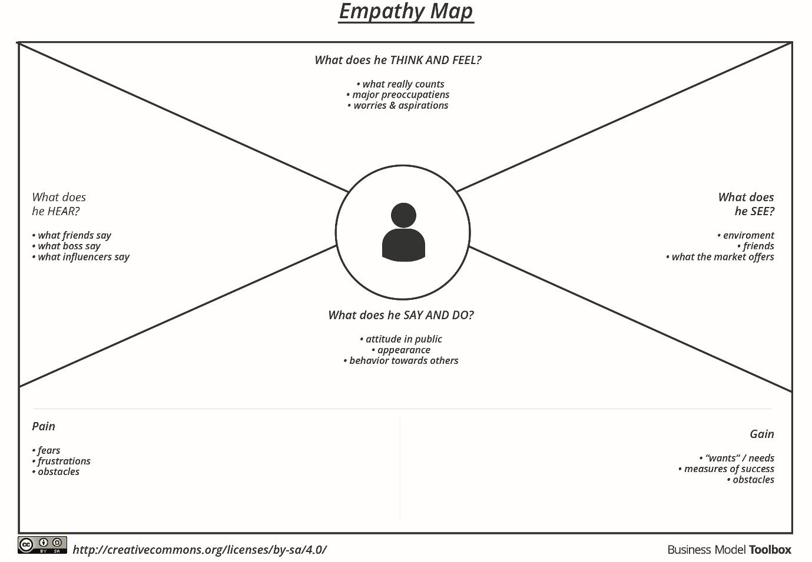

User Stories
User Type | Epic | Story ID | User Story | Acceptance Criteria | Priority | Release
Customer | Authentication | US-001 | Register/Login securely | Account created and login successful | High | Sprint-1
Customer | Products | US-002 | Browse, search and filter products | Products displayed correctly | High | Sprint-2
Customer | Wishlist | US-003 | Add/remove wishlist items | Wishlist updated | Medium | Sprint-2
Customer | Cart | US-004 | Add/update cart | Cart totals updated | High | Sprint-3
Customer | Checkout | US-005 | Place order securely | Order created | High | Sprint-3
Admin | Product Mgmt | US-006 | Add/Edit/Delete products | Catalog updated | High | Sprint-4
Admin | Order Mgmt | US-007 | Manage customer orders | Order status updated | High | Sprint-4
Admin | Dashboard | US-008 | View analytics | Dashboard loads reports | Medium | Sprint-4

